by Markus Krugel

Progress report

of the Project „Creature Generator“

Table of Contents

Goals and purpose: 2

Algorithms and Concepts 2

Poisson disc sampling: 2

Superformula: 3

Divago system: 3

variational auto includer: 4

Multi-resolution surfaces 5

Lindenmayer system: 5

metaballs: 5

rigblocks 5

Potential solutions 6

My approach 6

Project Plan 6

Gantt chart 6

References 6

# Goals and purpose:

The minimum goal of this project is that the user can set the settings and then a monster, with basic body parts merged into a single mesh, will be generated. Furthermore, the user will have the ability to export the monster model so that they can use it outside of this project, for example in a 3D modelling software. When I reached the basic goal and still have time remaining, I will consider implementing other features like additional body parts or further control for the user on the creature generation inside the editor.

Procedural generation takes a big part of the video game industry as seen in their big role in genres like roguelike or endless runners. While the generation of worlds and levels are the main purpose of procedural generation in games, the generation of creatures are rarely seen. Only a few games like No Man’s Sky tackle this issue. My intention behind this project is to explore possibilities in the creation of creatures as I can see many benefits it can have for the video game industry.

One advantage is that artists can use these generated models as a start to create unique monsters or even inspire them to create ones on their own. Moreover, it can help to reduce the time and cost behind developing the creatures as they can be generated instead of being modelled from the ground. The procedural generation of creatures can be also interesting for the players as it can motivate them to explore the world as they can see more of these unique creatures. One example for the last advantage can be seen in the mentioned game No Man’s Sky as some players like to spend more time exploring due to these vastly different creatures.

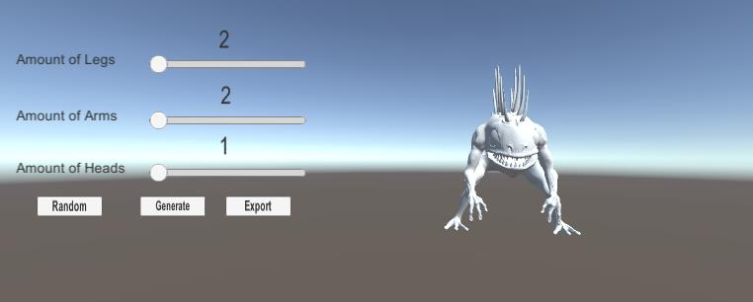

*Early design for GUI*

# Potential Solutions

## Poisson disc sampling:

Poisson disc sampling is an algorithm to generate multiple objects which have a minimal distance between each other, so that they do not collide.

Instead of just spawning the object randomly and then going through every existing object to check if they are colliding, we implement a grid system. The objects now have the length of a cell’s diagonal as their radius so that it is guaranteed that they fill the cell despite their position inside the cell.

Furthermore, because of their radius size we only have to consider a 5x5 area with the cell as its center, which helps vastly to improve the efficiency (Sebastian Lague 2019).

This easily implemented algorithm can be used for the project to place the body parts on the body without fearing that they collide with each other.

On the other side this algorithm does not help with the problems of creating the body parts and the combination of these into a single mesh. Moreover, we have to constraint the places where the body parts can spawn as this can result into strange creatures, for example the feet could be spawned on the upper part of the body where they would be useless.

## Superformula:

The superformula is an algorithm, proposed by Johan Gielis around 2000. This formula is a combination of the equations for spheres, eclipses and the superellipse and can be used to create different shapes.

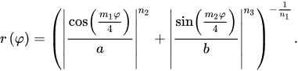

The values of the parameters a, b, m1, m2, n1 and n2 can be changed to achieve different results. The m parameter is responsible for the rotational symmetry while a and b control the size. The other three parameters control the curvature of the sides [9]. As this equation can only have two dimensional results, we have to multiply two different superformulas as following:

https://lh6.googleusercontent.com/E3NqWr5N5_BkHinwp3w2GyZdWQoppK_JrTIFerCeEskcosByyP_KaLJrR6OZyxRrVSg8EZK3VDSlqWOYXoCMIW8pPt3uW9K8AiAnC9Las8J-8l1dirZF34LW8oYBKwRWClh5SnLQ

https://lh5.googleusercontent.com/7OuOEsbnZYKZORiA_0ixXMmsqz12HXkkAuW-JAjNKMwRAYg63lUKtU_vhffcB_0JoT70V-9xKeUBEvPuwt3DuG7WI79yqv0S62LTpM2RzvsAvjxtkZrv4ovUAVZa78hI662b1-aV

https://lh4.googleusercontent.com/2o1F4hsFcBpSPUL6Uf-82np71QJioRwLA5YFsrA-rFdIQ_auA_ZpDIdr8hoS98wbKgZNEKrwuiv5xhg80Mlzb9cxAssgb0hpbIn9nL8cwEbqKxdA-Fxf9Dq9jAHBL6lVc7tM6dJJ

The https://lh6.googleusercontent.com/bqkLQ0L0-MMBGufaJ1TZnIaHhbDSPmwuWMnT_0bS5j5H0nIzwzgFdmP8wxDc5njYOtQWyxocTq_TfA-klfOF3rRs3AtTEwHZ6OVLzFa-Xl8Ear6yXw1jyU-fGqaaR3UvR6Q9EXvq can only have values between -*π*/2 and *π*/2 while *θ* stays between -*π* and *π* (Wikipedia 2019)*.*

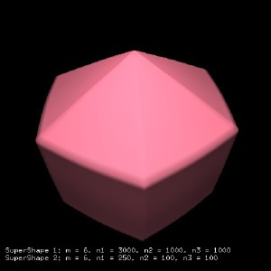 [10] 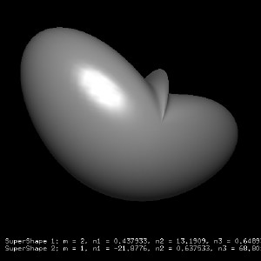 [11]

*Examples of Supershapes in 3D.*

This formula could generate different shapes to be used as the body or for the body parts. Also, it is easy to use because you only have to change the values to have different shapes.

On the contrary it could generate shapes which are not usable to use, and it could be hard to find the usable shapes. Furthermore, there is unfortunately an active patent on this formula so that I cannot use it for this project.

## Divago system:

The goal of the Divago system is based on conceptual blending and is used to create a unique object by blending two different objects using knowledge gained by previous blends.

Conceptual blending uses mental spaces which are knowledge structures regarding an object. We can bend two mental spaces by mapping different elements of the mental spaces with each other. Following we have an example of the mental spaces and how the mappings can look like.

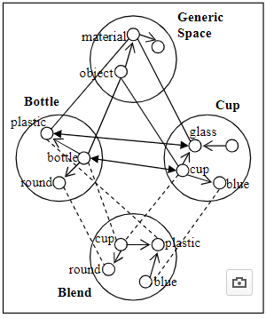 [11]

*Diagram for Conceptual blending*

Divago system works with two input domains and a generic space domain similar to conceptual blending which will contain the knowledge gained by previous blends.

There are four phases in the divago system: mapping phase, projection phase, elaboration phase and the validation phase.

The mapping phase will start the mapping between the two inputs with the help of the domains. After the mappings in the projection phase the blending will begin by searching for the optimal blend bases on the mappings. The next step is the elaboration phase where the blend is refined and altered with the knowledge of the domains. At last the blend will be tested in the validation phase if it does not violate any rules.

Ribeiro et al(2003) uses following architecture for their creature generator described in their article:

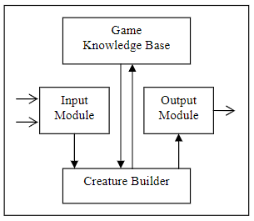[12]

*Architecture of a creture generator using divago system*

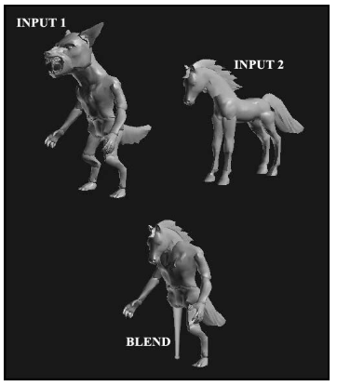[13]

*Example output*

One disadvantage of this approach is that you need a few models beforehand as without the required inputs this system does not work. As many learning algorithms it can take many data example before getting good results. Furthermore, the variations in the resulted blend can heavily be influenced by the differences between the inputs, which means that the data examples should have many differences to have varying results.

On the other hand, once this system is trained the results could be very promising as it learns to understand how the creature should be generated.

## Variational auto encoder:

Variational auto encoders are being used to generate an image based on the knowledge of previous images.

This system consists of the encoder, the decoder and the loss function. The encoder is a neural network where the input will be encoded to a result with lower dimensions than the input, which is often referred as the bottleneck. To achieve this result the encoder has to learn to efficiently compress the input so that the output can be used for the decoder.

Like the encoder the decoder is also a neural network. Inside the decoder the results given by the encoder is being used to reconstruct the original input. As it goes from a smaller to a bigger dimension again there will be a loss of information.

To learn with every iteration there is also a loss function to calculate the difference between the input and the result given by the decoder. The formula for this calculation is the following:



The first term is called the reconstruction loss where we calculate if the decoder reconstructed the image well enough. The second part is a regularizer using Kullback-Leibler divergence to calculate the loss between input given and the result from the encoder. To improve the next iteration, we use the data gained from the loss function to update the parameters of the encoder and decoder(Altosaar, 2019) .

As with many learning algorithms the problem of this approach is that we need a large dataset to guarantee a satisfying result. Also, it needs an input to create a result which is not fitting for this project since we want to generate a model without the need of a model beforehand.

## Lindenmayer system:

The Lindenmayer system or also known as L-System is a string rewriting algorithm developed by Aristid Lindenmayer in 1968.

You start with a base string and with each recursion you replace the chars of the string based on the rules you set beforehand.

Following we have an example of this algorithm. We start with the string “E” and the rules are “E = ER” and “R = E” which means that with every recursion we replace the all E’s in the string with “ER” and all R’s will become E’s.

n=0:         E   
            / \  
n=1:       E R

         /| \  
n=2:     E R E          
        /| |   | \  
n=3:   E R E   E R

    / | | | \   |\ \  
n=4: E R E E R  E R E

So, after four iterations our initial string of “E” have become the string “EREERERE”. At the end we will execute operations based on the letter. In this example “E” means “Extrude” and ”R” is “Rotate”.

For our cause a stochastic grammar would be more useful as it can have different results. As an example we can change the rules from the previous example by saying there is a 50% chance of “B = B” and the remaining 50% will result in “B = F”.

An advantage of this algorithm is that it is easy to understand and to implement. Additionally you can easily modify the rules if the results are not satisfying.

The biggest problem with this approach is to find a correct grammar to generate acceptable creatures.

## Metaballs:

Metaballs are organic objects which will merge with each other if they are nearby.

The metaball can be seen as a particle surrounded by a density field, where the density depends on the distance to the particle position (Kenwright, 2019). Each meatball is defined as a function with a thresholding value to define the solid volume.



To render the metaballs we use the marching cube algorithm, which will generate an approximation of the contour line for the metaballs. By taking eight neighbor locations and therefore creating an imaginary cube we can detect the parts the metaball will fill in the cube. After checking all 8 points with the values of the metaball we can assume the shape of the metaball.

The game Spore uses metaballs inside the creature generator to build the body of the creature, which enables an intuitive way to create the creatures.

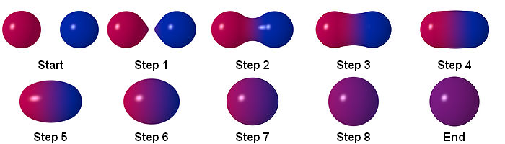

*Example of the interaction between two metaballs*

## Rigblocks

Rigblocks are models with components, like the width of the nostrils, which can be modified by the user.

The game „Spore“ uses this system inside their creature editor so that the player can deform and modify the body parts to their liking [3].The developers behind spore used sliders to change the components because they are intuitive for the player to use. Additionally, these models also contain animations, which are being played when the user deforms the model so that there is a fluent transition between the old and new state [8].

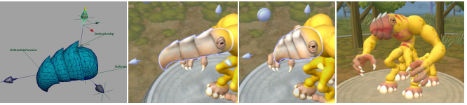[14]

*On the left we see the model with its handles, the following images show possible deformations*

As seen in Spore this system is really helpful in creating quality body parts, which can be deformed and therefore have many variations. Furthermore, this could help to implement features similar to Spore’s creature editor where the player can adjust the creature inside the editor after the generation.

The problem for this system to this project is that the integration of these body parts with the body could be difficult because we have to find a solution to combine the different meshes into a single mesh without strange deformations of the body or the body parts.

# My approach

My approach to that project is a combination of the Metaballs and the Lindenmayer system. I chose the combination of both because both harmonize well with each other.

With the help of the Lindenmayer system I can place the body parts based on the grammar and then refine these body parts with each iteration. Furthermore, this system is also really cost efficient as it only must rewrite the string with each iteration instead of doing complex calculations. The base rules of my grammar would consist of changing the position and rotation and in spawning different metaballs. As mentioned in the metaballs explanation we will use stochastic grammar so that we have varying results.

The metaballs on the other hand can be easily generated and because of the merging of the metaballs with each other I do not have to worry about the connection between the body parts. The shape of the metaballs can also be easily modified by using different formulas and threshold values, which helps greatly in creating different creatures. As seen in the creature editor inside of the game Spore, metaballs are useful to generate and display creatures.

I have decided against the divago system and the variational auto encoder as they have to be trained to give satisfying results and I do not have the required amount of data nor the time needed to create or collect these data. Poisson disc sampling was considered but because of their lack of integration of the body parts not fitting for this project. I would have used the superformula to create unique shapes to use as body or body parts but because of the active patent I am not allowed to use this formula. Similar to poisson disc sampling I will not use rigblocks as I have to worry how to integrate them.

# Project Plan

## Gantt chart



## Flow diagrams

### Project

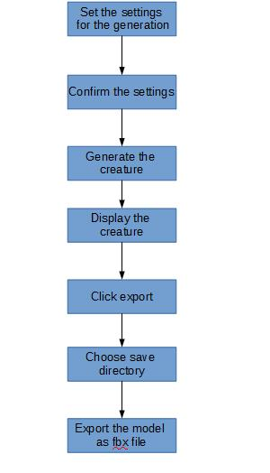

### Algorithm

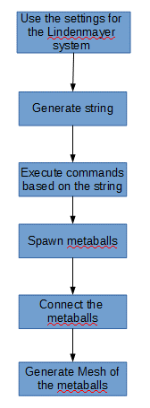

## Pseudo Code

### Lindenmayer system

for(int i = 0; I <= iterations; i++)

Replace letters of string based on rules

Foreach(char in string)

executeCommand(letter)

# References

## Github

<https://github.com/Markus-Krugel/Creature_Generator>

## Text

1. Ribeiro, P., Pereira, F., Marques, B., Leitão, B. and Cardoso, A. (2019). A Model for Creativity in Creature Generation. In: *4th International Conference on Intelligent Games and Simulation {(GAME-ON}*. [online] London: EUROSIS, p.5. Available at: <https://www.researchgate.net/publication/221024396_A_Model_for_Creativity_in_Creature_Generation> [Accessed 27 Feb. 2019].
2. [Unity] Procedural Object Placement (E01: poisson disc sampling) (2019) YouTube video, added by Sebastian Lague [Online]. Available at <https://www.youtube.com/watch?v=7WcmyxyFO7o> [Accessed 27 February 2019].
3. Hecker, C. (2014). *My liner notes for spore*. [online] Chrishecker.com. Available at: <http://chrishecker.com/My_liner_notes_for_spore> [Accessed 27 Feb. 2019].
4. ‘Metaballs’ (2019) *Wikipedia.*Available at <https://en.wikipedia.org/wiki/Metaballs> (Accessed: 27 February 2019).
5. Wong, J. (2014). *Metaballs and Marching Squares*. [online] Jamie Wong. Available at: <http://jamie-wong.com/2014/08/19/metaballs-and-marching-squares/> [Accessed 27 Feb. 2019].
6. ‘Superformula (2018) *Wikipedia.*Available at <https://en.wikipedia.org/wiki/Superformula> (Accessed: 27 February 2019).
7. Velho, L., Perlin, K., Biermann, H. and Ying, L. (2002). *Algorithmic shape modeling with subdivision surfaces*. [ebook] New York: IMPA—Instituto de Matematica Pura e Aplicada, pp.865 - 875. Available at: <https://web.stanford.edu/~lexing/asmss.pdf> [Accessed 27 Feb. 2019].
8. Choy, L., Ingram, R., Quigley, O., Sharp, B. and Willmott, A. (2007). *Rigblocks: Player-deformable Objects*. [ebook] Electronic Arts. Available at: <http://www.cs.cmu.edu/~ajw/s2007/0248-Rigblocks.pdf> [Accessed 27 Feb. 2019].
9. Norato, J.A. Struct Multidisc Optim (2018) 58: 415. <https://doi.org/10.1007/s00158-018-2034-z>
10. Weber, S. and Weber, S. (2019). *Poor Man’s Sky: Experiments with Procedural Generation of Characters*.[online]Making Games. Available at: <http://www.makinggames.biz/feature/procedural-generation-characters,12342.html> [Accessed 28 Feb. 2019].
11. Altosaar, J. (2019). *Tutorial - What is a variational autoencoder?*. [online] Available at: <https://jaan.io/what-is-variational-autoencoder-vae-tutorial/> [Accessed 1 Mar. 2019].
12. Kenwright, B. (2019). *Metaballs & Marching Cubes*. [ebook] Available at: <http://www.xbdev.net/misc_demos/demos/marching_cubes/paper.pdf> [Accessed 1 Mar. 2019].

## Images

1. Bourke, P. (2002). *Example 1 of Supershape in 3D*. [image] Available at: <http://paulbourke.net/geometry/supershape/C_0009s.jpg> [Accessed 27 Feb. 2019].
2. Bourke, P. (2002). *Example 2 of Supershape in 3D*. [image] Available at: <http://paulbourke.net/geometry/supershape/C_0022s.jpg> [Accessed 27 Feb. 2019].
3. Cardoso, A. (2003). *Conceptual blending figure*. [image] Available at: <https://www.researchgate.net/publication/221024396_A_Model_for_Creativity_in_Creature_Generation> [Accessed 27 Feb. 2019].
4. Cardoso, A. (2003). *Divago system figure*. [image] Available at: <https://www.researchgate.net/publication/221024396_A_Model_for_Creativity_in_Creature_Generation> [Accessed 27 Feb. 2019].
5. Cardoso, A. (2003). *Outcome of the Divago system*. [image] Available at: <https://www.researchgate.net/publication/221024396_A_Model_for_Creativity_in_Creature_Generation> [Accessed 27 Feb. 2019].
6. Choy, L., Ingram, R., Quigley, O., Sharp, B. and Willmott, A. (2007). Example of a rigblock. [image] Available at: <http://www.cs.cmu.edu/~ajw/s2007/0248-Rigblocks.pdf> [Accessed 28 Feb. 2019].
7. Author unknown (2019). Example of metaball interaction [image] Available at: <https://upload.wikimedia.org/wikipedia/commons/6/6d/Metaball_contact_sheet.png> [Accessed 1 March 209].

## Model for GUI prototype

<https://free3d.com/3d-model/murloc-93031.html>